Assignment 1: Azure Storage

Question 1:

Create a storage account with the name: yourname+yourdob

While making ensure it is in the resource group name: - Azurelib-Academy and the region is US-east
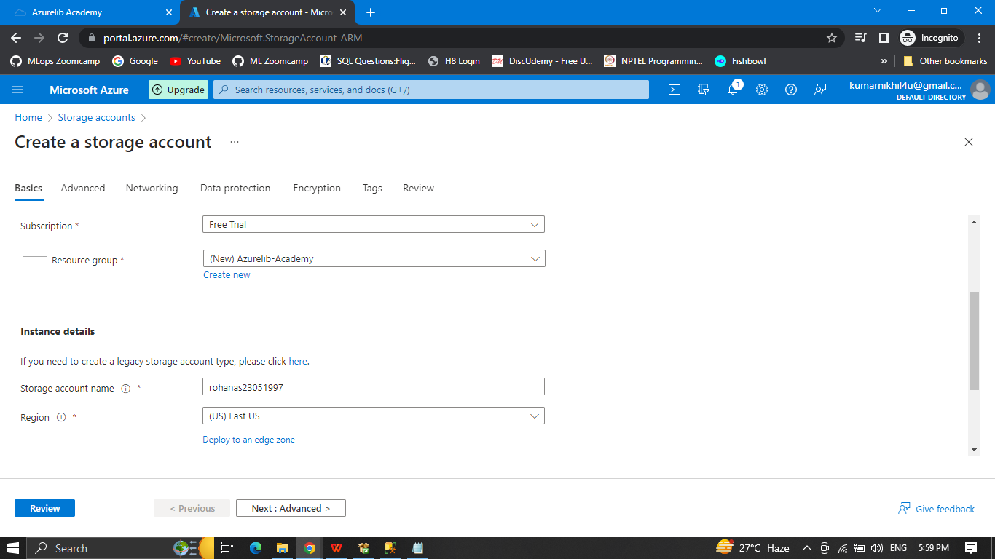

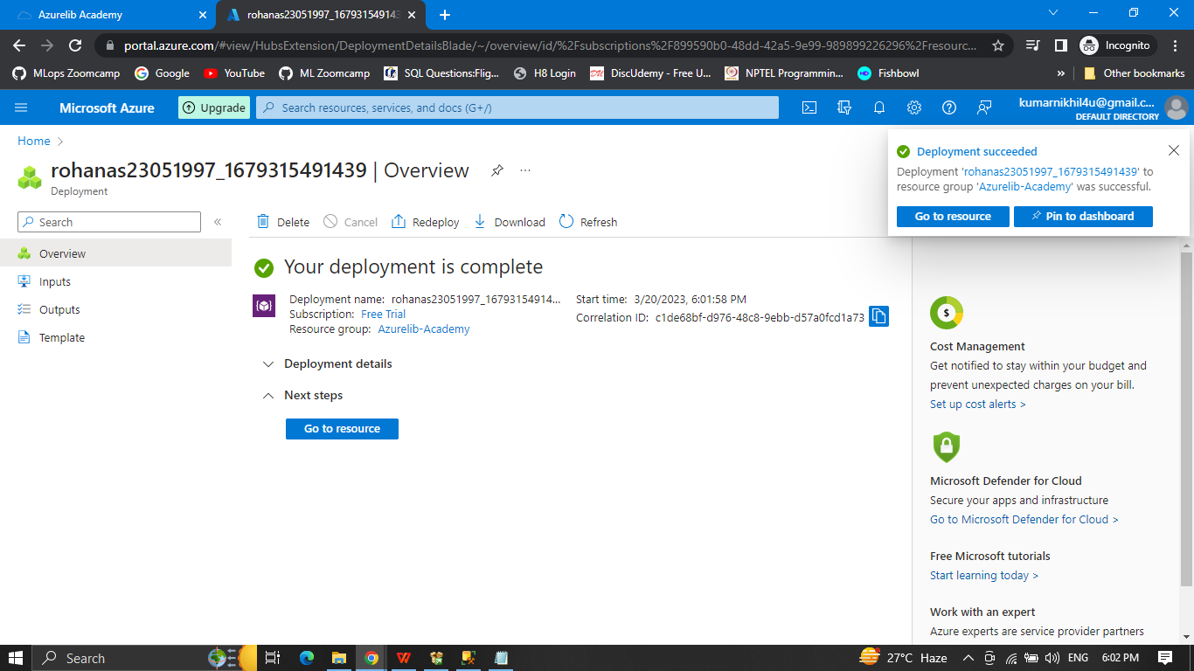
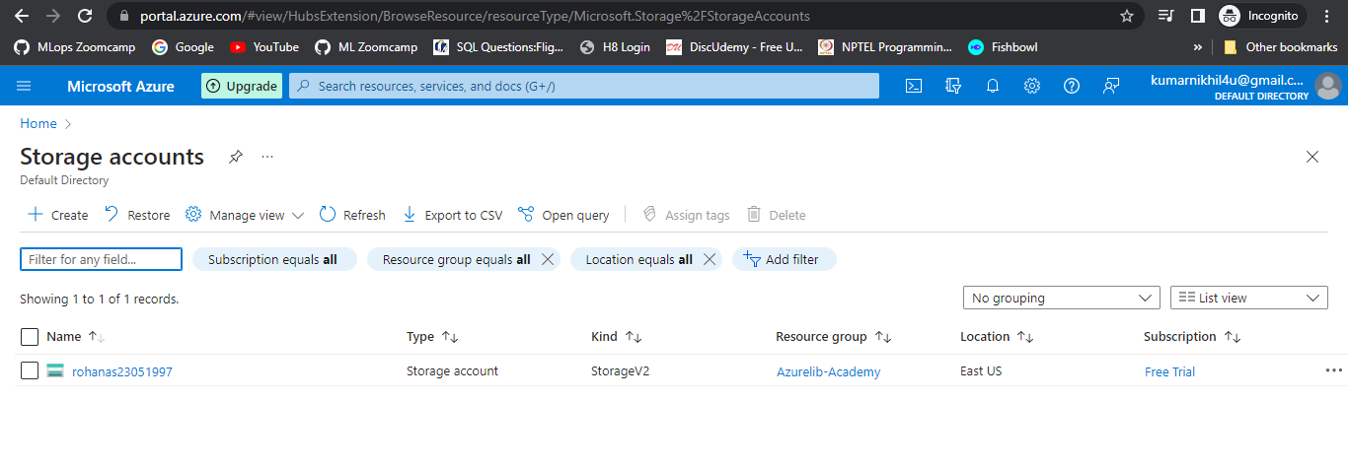

Create a container name landing (publicly accessible)
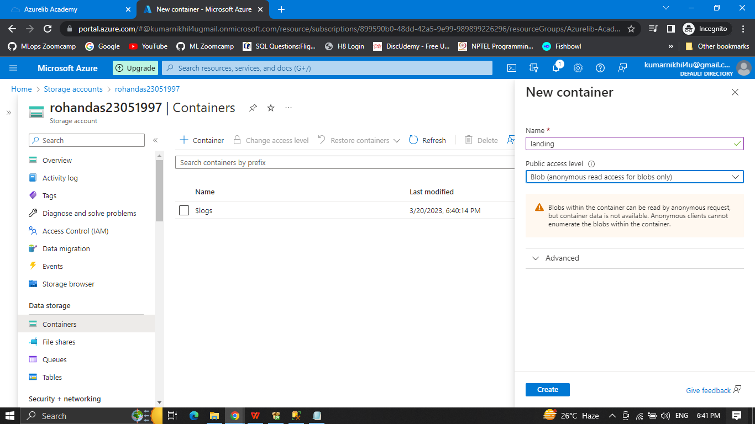

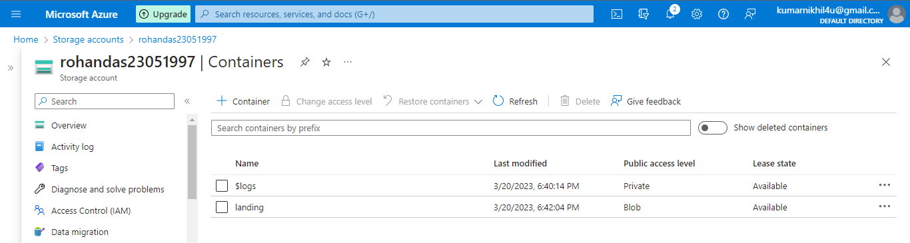

Create another container name landing private (publicly not accessible)
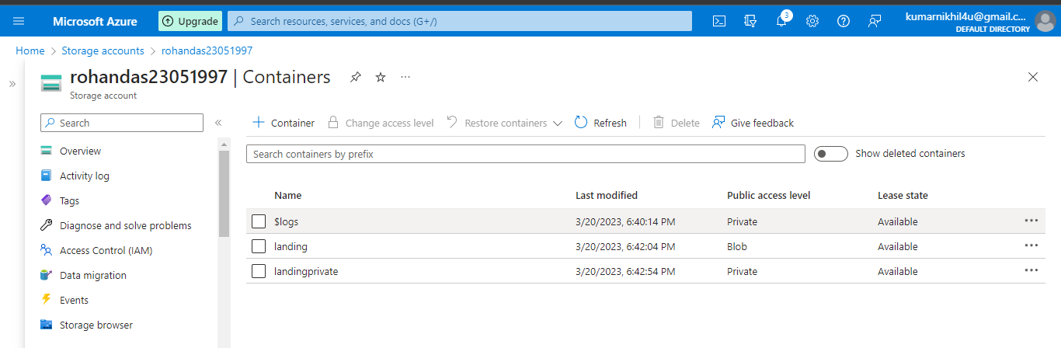

Upload any text file in both container.
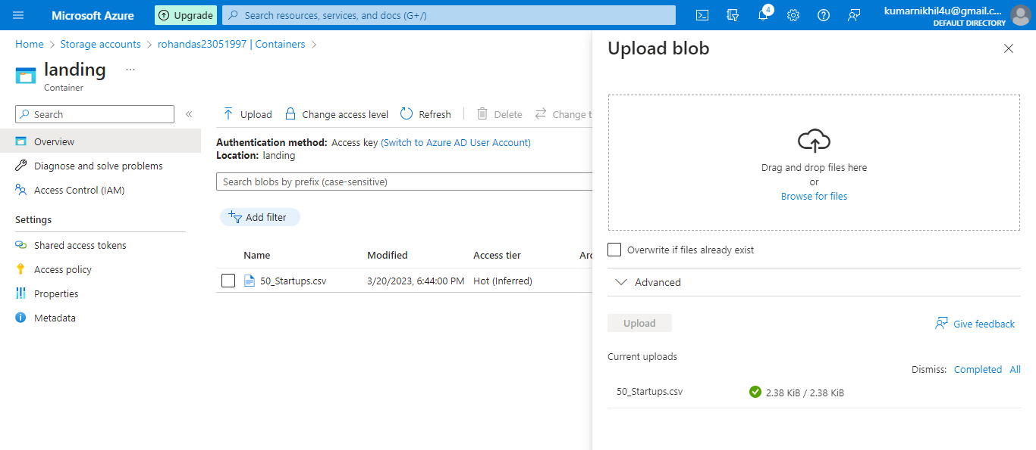

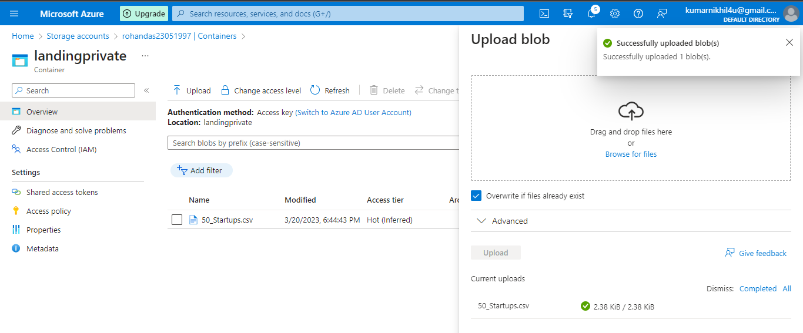

Create a SAS token which is valid for the next 2 days to access your files.
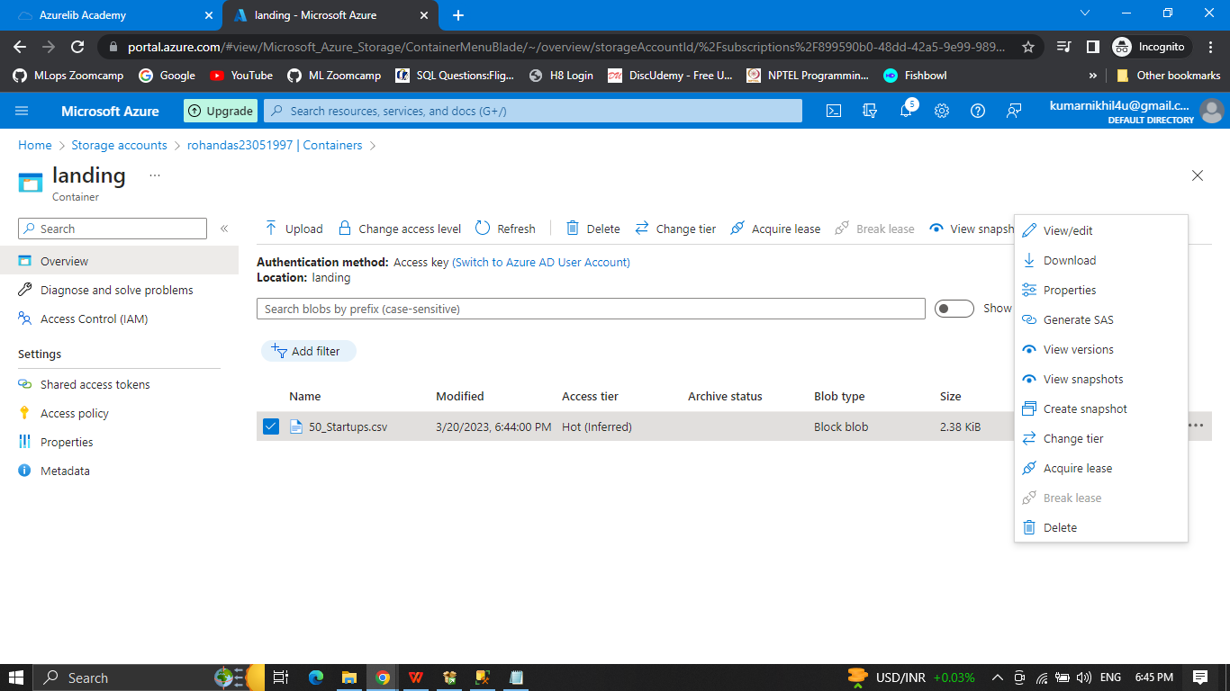

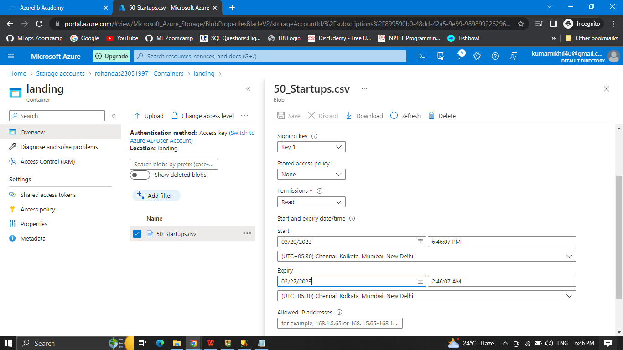

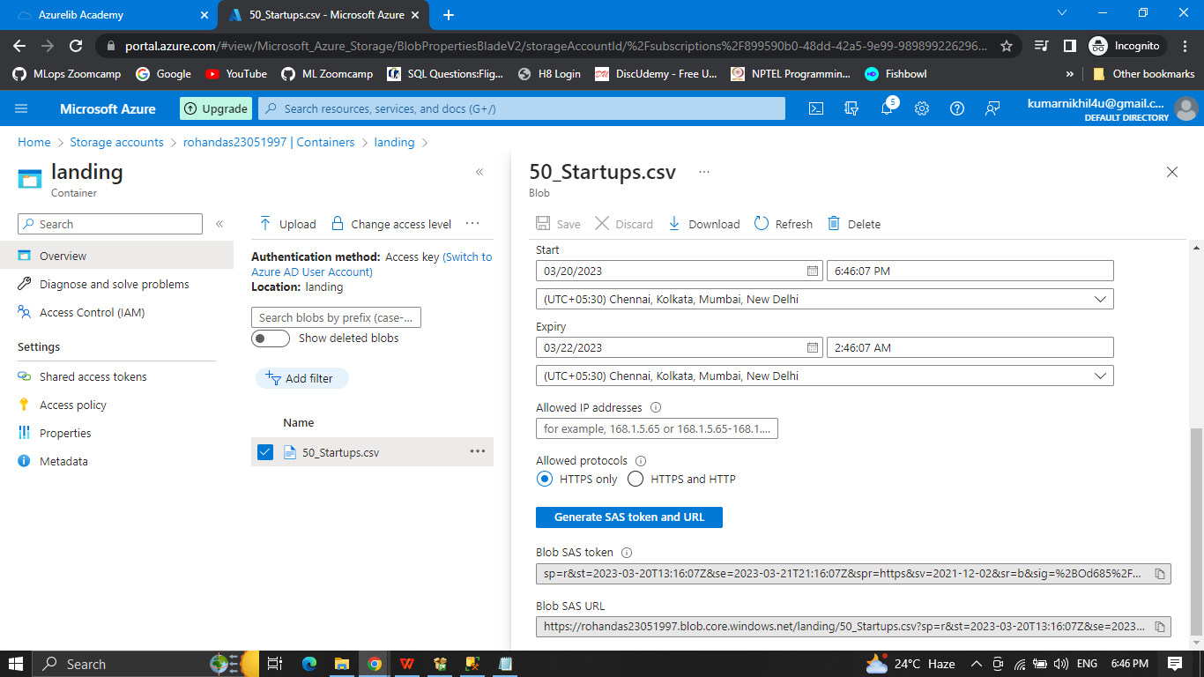

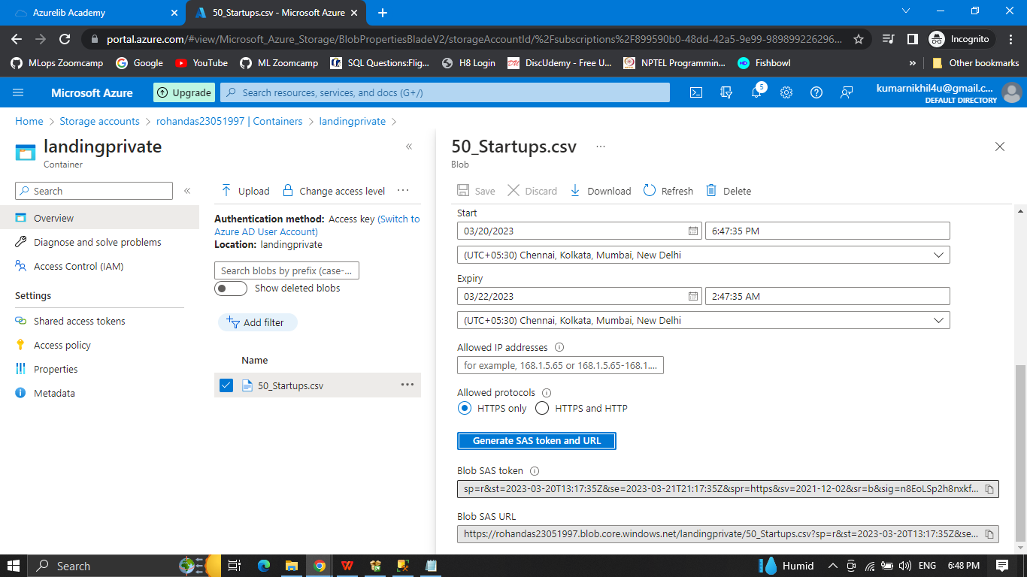

7. Attach the screenshot under the comment in the course chapter.

8. Delete the azure storage account you have created to stop the charges.

9. Share it on LinkedIn with all of us. Tag #Mission100AzureDataEngineer

Question 2:

Create a ADLS storage account with the name: yourname+yourdob+adls

While making ensure it is in the resource group name: - Azurelib-Academy and the region is US-east
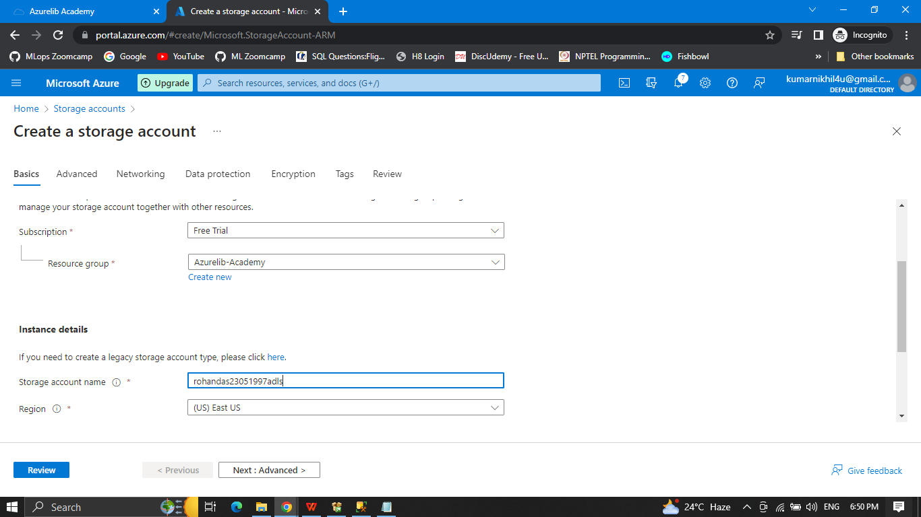
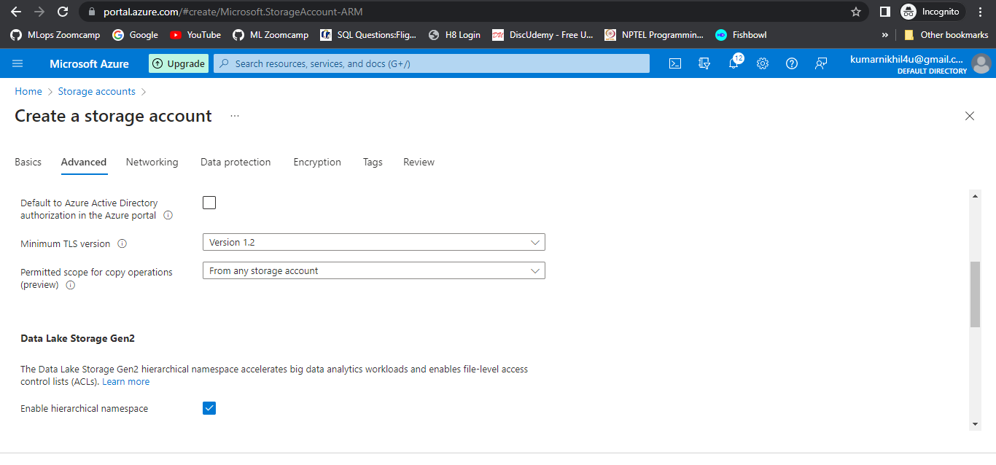

Try to change the soft delete time for 7 days to 10 days.
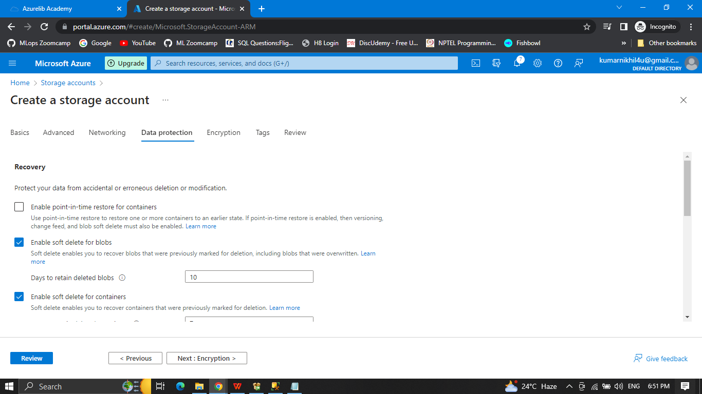

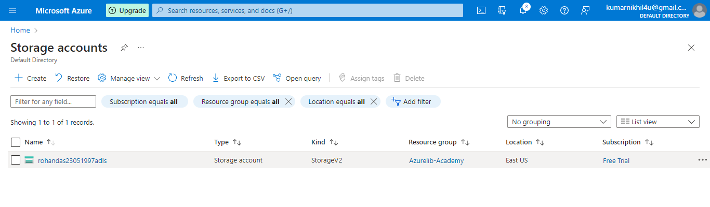

Create a container name landing (publicly accessible)
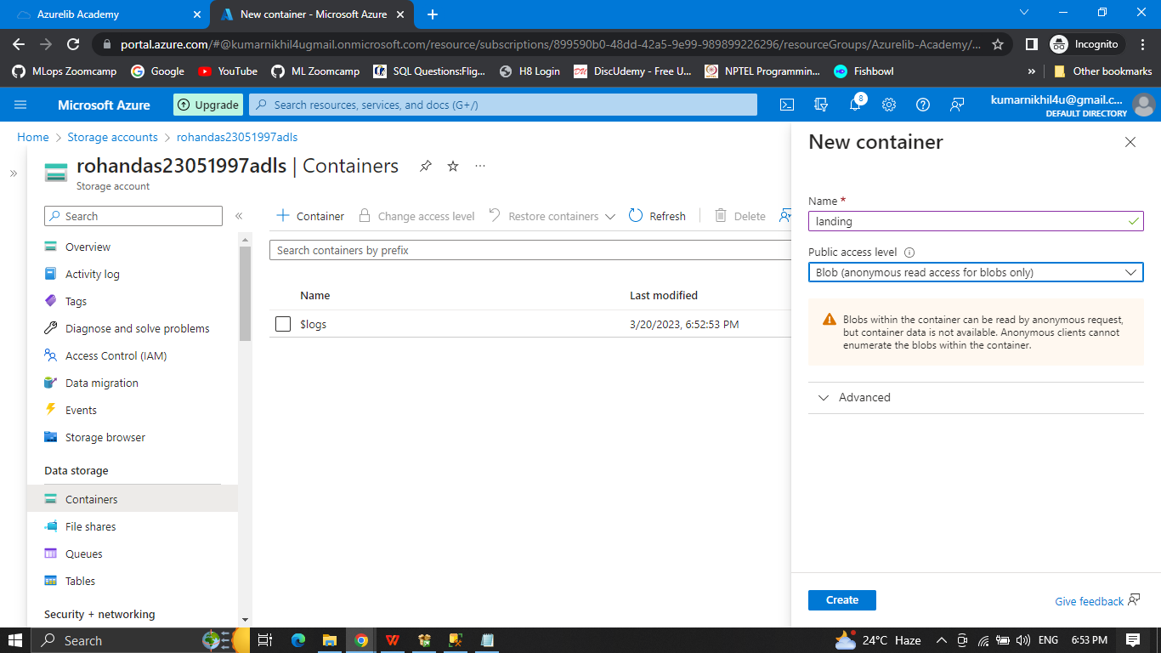

Create another container name landing private (publicly not accessible)
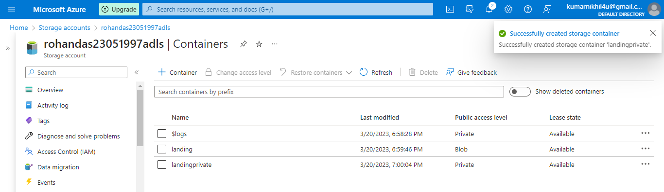

Create a directory Practice-1 in both container
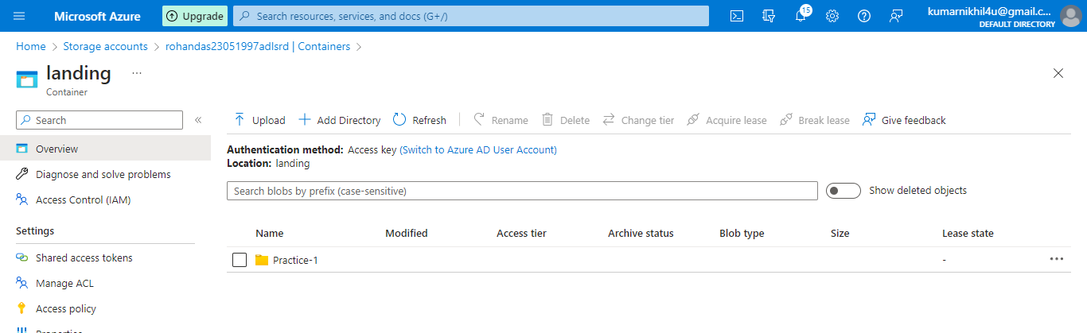

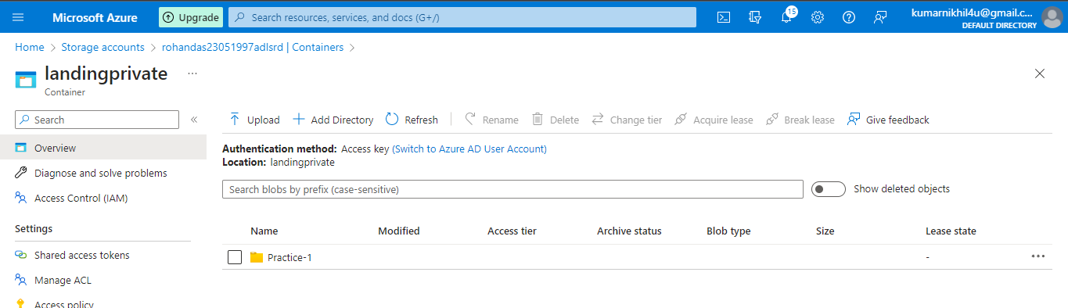

Upload any text file in both container inside the Practice-1.
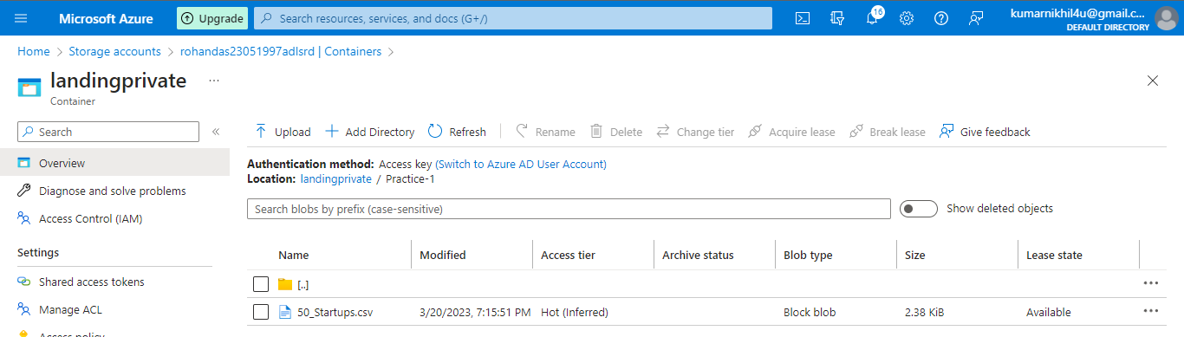

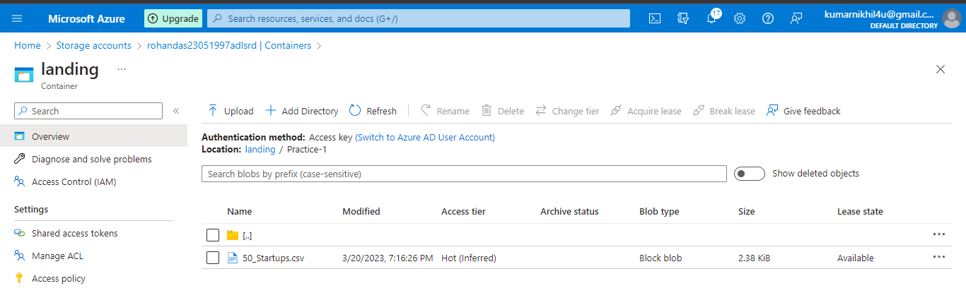

Delete the file just uploaded
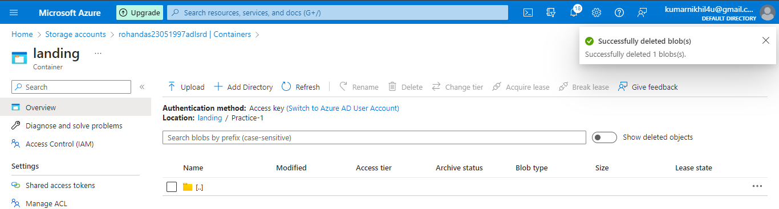

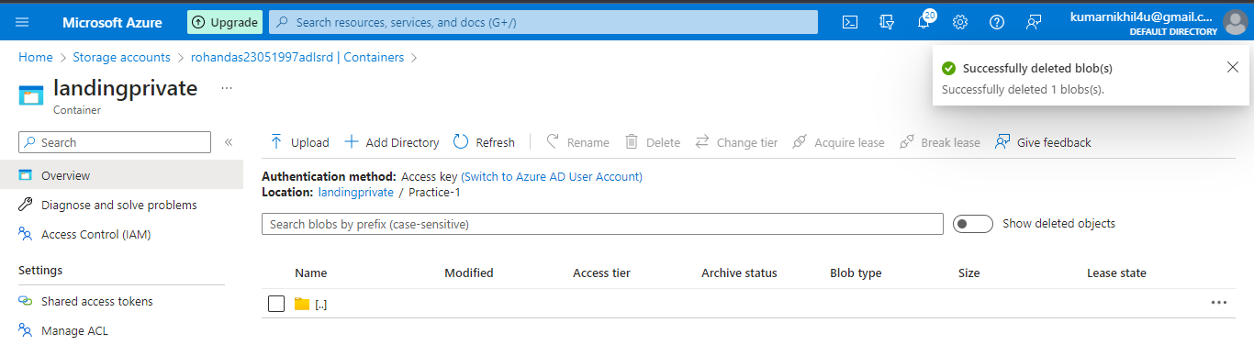

Try to restore the deleted file.
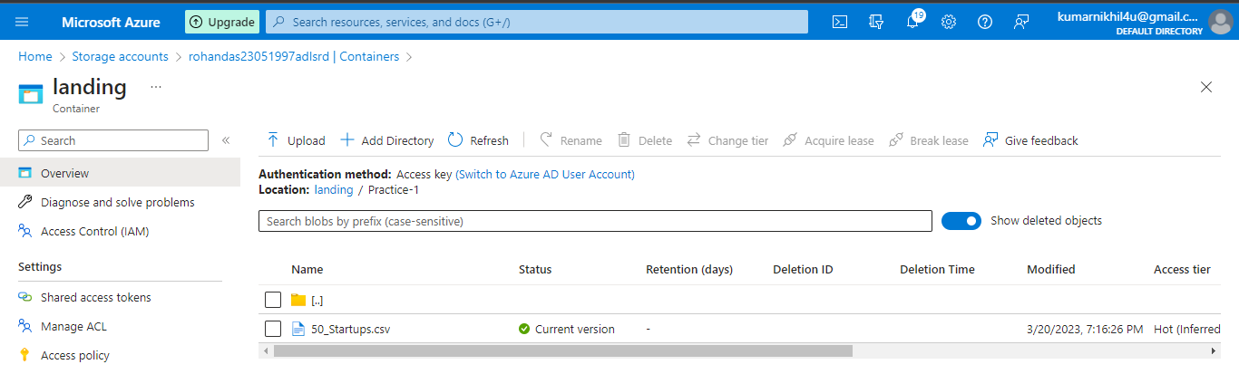

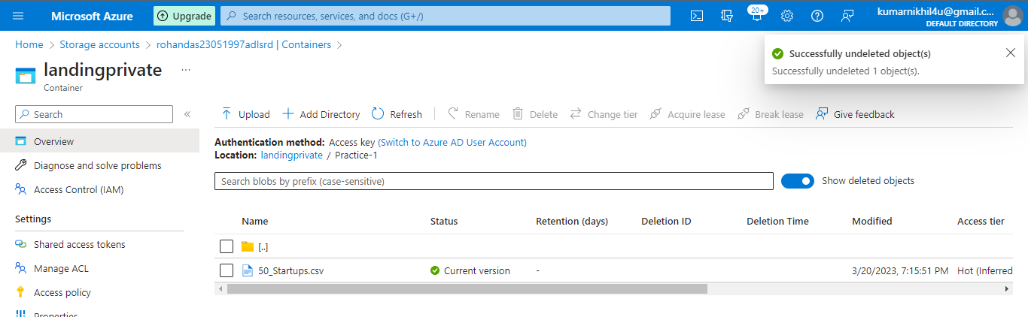

10. Attach the screenshot under the comment in the course chapter.

11. Delete the azure storage account you have created to stop the charges.

12. Share it on LinkedIn with all of us. Tag #Mission100AzureDataEngineer

